Project Tracker

Wireframe

# Layout of pages

1. Landing Page:
   1. Inspired by Monday.com, the landing page can have a “Sign Up” button and some description about the website.
      1. [monday.com | Your go-to work platform](https://monday.com/?utm_medium=cpc&utm_source=bingbrand&utm_campaign=us-en-prm-workos-work_mgmt-brand-e-search-desktop-core-bing&utm_adgroup=monday.com&utm_content=monday.com&utm_keyword=monday.com&utm_match_type=e&utm_bid_match_type=be&utm_vertical=o&cluster=&subcluster=&msclkid=964ba3451639139d292bc52e092174cb)
      2. Logo options:
         1. A logo with a dart in the center

            Description automatically generated
         2. A close-up of a logo

            Description automatically generated
      3. Tag Line : “Your Productivity, Elevated.” Instead of “Your Go-to work platform”, we can write our tag line.
      4. Tag line description : “Keep all your tasks organized in one convenient platform”
      5. Instead of Video on the right side, let’s just keep an image for now.

With 





* + 1. Example:

1. Login Page:

1. Get Started Page: A screenshot of a computer screen

   Description automatically generated
2. Home Page:

3 dots Modal-

Edit Modal-

Assigned To: Should contain a field, with a + to add further fields, and – besides each field to delete it.

Completed Tasks: Should contain points with radio buttons-

*Moved From Active Tasks list when the radio button is clicked.

*New created Tasks, that were already completed when the new project is being created.

Active Tasks: Should contain points with radio buttons.

Delete Modal-

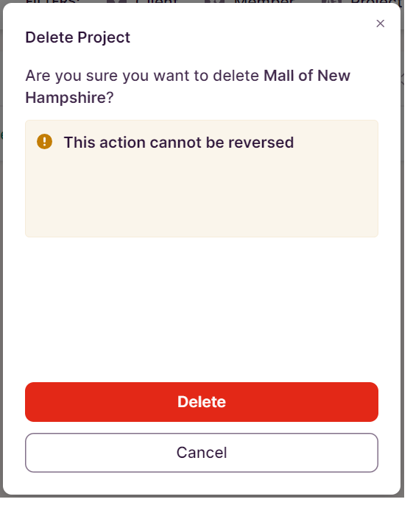

1. My Work Page: A screenshot of a computer

   Description automatically generated